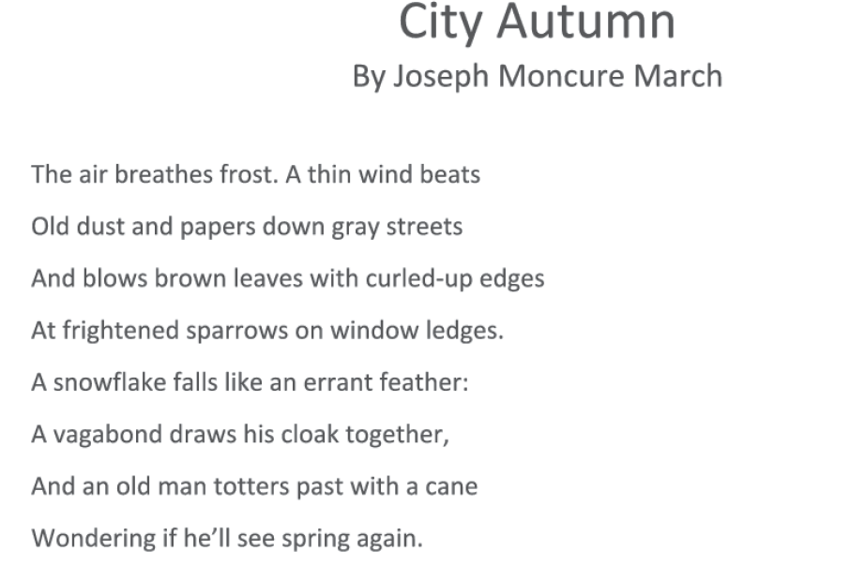

Look up the following words:
1. Errant ___________________________________________________________________
2. Vagabond
___________________________________________________________________
3. Totters
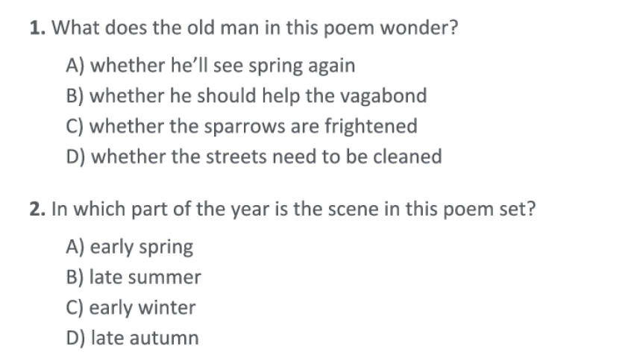
___________________________________________________________________

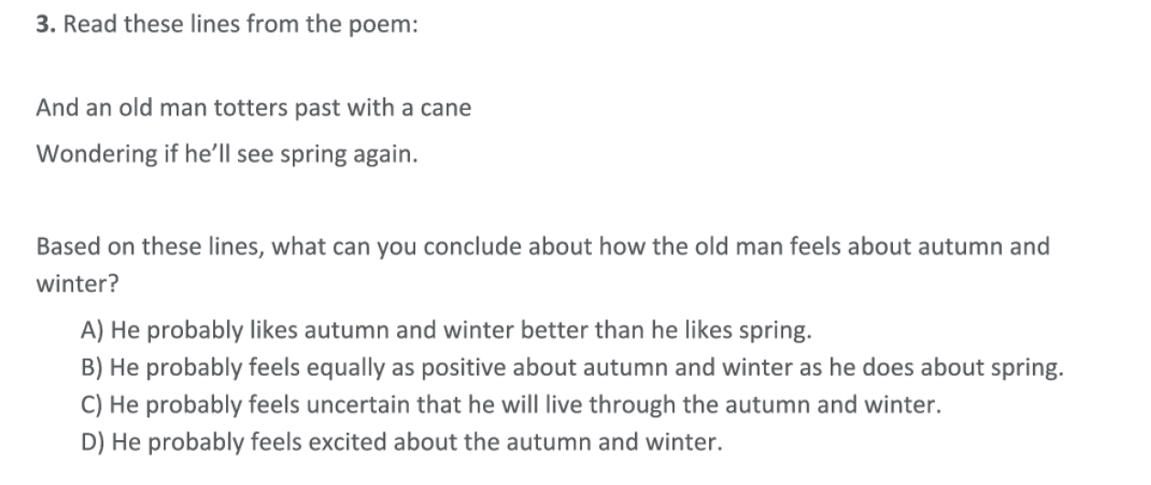

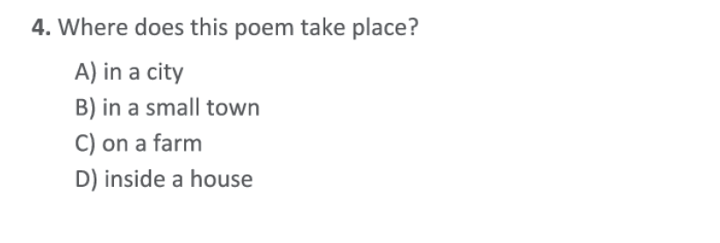

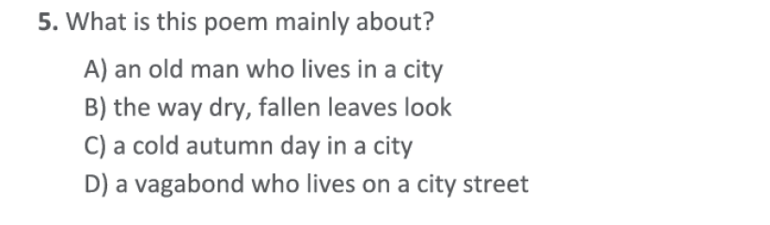

Detail #1 ____________________________________________________
Detail #2 ___________________________________________________

____________________________________________________________________________________________________________________________________________________________________________________________________________________________________________________________

