Name: _________________________ Parents Signature: ___________________________
Tuesday:
- Evaluate each expression. (Use the order of operations rules)

- 3 + 5 x 4 = b. 15 – 6 + 2 = c. (9 – 4) x 4 = d. 7 x 3 – 3 x 4 =

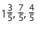
Wednesday:
Place the following numbers on the number line.
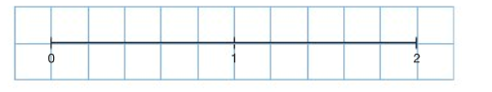

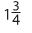
Place the following numbers on the number line.
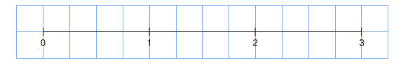
(Remember to change them to equivalent fractions with the same denominator)

Thursday:
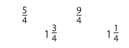
Convert the following numbers to either improper fractions or mixed numbers.

