Name: _________________________ Parents Signature: ___________________________
Monday:
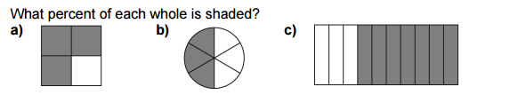

Percent: __________ Percent ________ Percent ________
Show Your work.

Tuesday:
