Name: _________________________ Parents Signature: ___________________________
Monday:
Are the ratios in each pair equivalent? Explain how you know.

- 7 to 14 and 21 to 28 b. 2 : 4 and 20: 40 c. 13 to 3 and 39 to 15

Tuesday:
- Multiple Choice Questions

- Which number can be read as 7 and 15 thousandths?

- 7.00015
- 0.715
- 7.015
- 7.0015

- Which expanded form is correct for the number 3.0056?

- 3 + 0.005 + 0.0056
- 3 + 0.005 + 0.0006
- 3 + 0.0005 + 0.00006
- 30 + 0.005 + 0.0006

- Which number can be read as 8 and 8 hundredths?

- 88.08
- 8.8
- 8.08
- 8.008
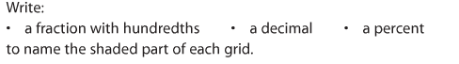
Wednesday:

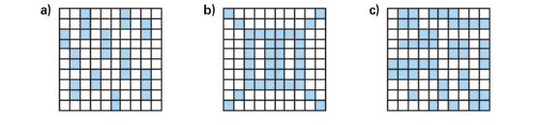

Fraction: Fraction: Fraction:
Decimal: Decimal: Decimal:
Percent: Percent: Percent:

Thursday:
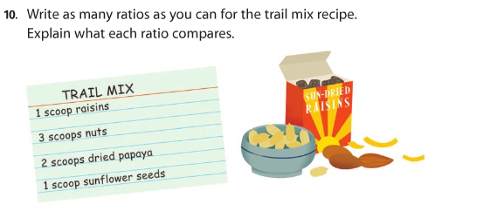

Show Your Work

