Name: _________________________ Parents Signature: ___________________________
Monday:
- Use the numbers in the box to write each ratio.
25 16 13 38 a. Odd numbers to even number ________________
17 30 49 3 b. Numbers less than 20 to all numbers _______________
24 45 7 14 c. Multiples of 5 to multiples of 7 ________________
d. Prime numbers to composite numbers __________________

Tuesday:
Draw some bats and some balls. Write as many ratios as you can for your drawing
Draw here Write your ratios here:
______ _______

______ _______

______ _______

Wednesday:
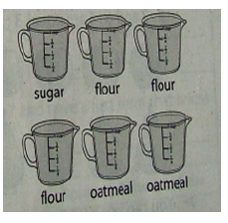
What is being compared in each ratio?
- 1 to 2 ________________________________

- 2 : 6 __________________________________

- 2 : 3 __________________________________

- 1/6 ___________________________________

Thursday:
- Write 5 multiples for the following numbers.

10

9

4

- Write ALL the factors for the following numbers

44

21

- Make a factor tree for the following composite numbers

36 54

