Comparing Ratios

RATIO – Is the comparing two quantities using the same unit.
Example: 11:15 (11 girls to 15 boys)
REMEMBER THAT THE ORDER OF THE RATIO IS VERY IMPORTANT
Example: 11 girls to 15 boys
11 : 15 CORRECT
15 : 11 INCORRECT

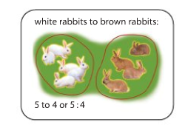
PART TO PART RATIO

- Comparing one part to another part

Example: Compare the white rabbits to brown rabbits 5 : 4
Compare the brown rabbits to white rabbits 4 : 5

PART TO WHOLE RATIO

- Comparing one part to a whole

Example: Compare the white rabbits to all the rabbits 5 : 9
Compare the brown rabbits to all the rabbits 4 : 9
