Name: ______________________
Weekly Homework
PLEASE BE NEAT AND DO YOUR BEST WORK
MONDAY:
- MULTIPLES:
- Write 10 multiples for 4

- Write 5 multiples for 9

- Write 7 multiples for 6

- FACTORS:
  - Write the factors for 30

  - Write the factors for 11

  - Write the factors for 18

TUESDAY:
ESTIMATING STATEGIES (IF YOU DO NOT HAVE ROOM, USE THE BACK OF THE PAPER)
The Blackville student council sold 45 T-shirts at $52 each and 32 sweatshirts at $47 each. How much money did the Blackville student council make in total?
- Estimate your answer first
- What operations (addition, subtraction, multiplication, division) will you use?
- Show your work

WEDNESDAY:
- Write the value of each underlined digit.

- 78 345
- 54 788 309
- 345 890 087

- Write a number that is:

- 100 000 more than 912 456
- 10 more than 45 698
- 1 000 000 than 34 567 900

__________________________________________________________________________________
THURSDAY:
- Describe whether the following data is discrete or continuous

- Bike helmets sold in the last 6 months _________________________

- Abby’s height from age 2 to 14 _______________________________

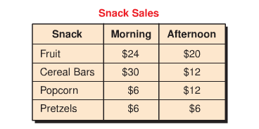
2 a. (YOU WILL NEED GRID PAPER)
- Decide on the appropriate graph.
- Create a graph
- Remember to label your graph appropriately
- Think about your scale

- Write 2 conclusions you can make from your graph.

- ____________________________________________________________________________

- ________________________________________________________________________

